Interfacial behaviour of plant proteins

Alexandre Poirier¹, Amélie Banc¹, Antonio Stocco², Martin In¹ and Laurence Ramos¹

¹ Laboratoire Charles Coulomb (L2C), UMR 5221 (Université Montpellier/CNRS) F-34095 Montpellier, France
² Institut Charles Sadron CNRS, UPR 22, 84047, Strasbourg, France

Challenges of public health and sustainable development require replacing in food products animal proteins by plant proteins. In this optics, it is crucial to understand the structure and kinetic of formation of a film of plant proteins in order to improve the control of emulsions and foams stabilized by these proteins.
In this talk we will present experimental results on the behaviour interfacial properties of wheat gluten, sunflower and rapeseed proteins at liquid interfaces. Thanks to a combination of tensiometry, dilatational rheology and ellipsometry, rational physical pictures of the dynamics of the interfacial properties are achieved, for the various proteins and at both air/water and oil/water interfaces.
For gluten proteins, a time-concentration superposition of the data is evidenced whatever the subphase concentration, which reveals that the kinetics of protein adsorption at the interface is dominated by bulk diffusion. We propose a consistent physical picture of the multistep diffusion-controlled irreversible adsorption of the gliadin proteins at an air/water interface, and evidence surface-induced conformational changes of the proteins followed by film gelation ^{[1]}.
Sunflower and rapeseed proteins by contrast do not reorganize once adsorbed at an interface and display a simpler dynamics of film formation. In addition the failure at high concentration of the time-concentration superposition of the tensiometry and viscoelastic data strongly suggest a surface-induced aggregation process, which we confirm with turbidity measurements.
By quantitatively comparing the surface pressure dependence viscoelasticity of the various interfaces, we hightlight the crucial role on the behavior of plant proteins at liquid interfaces of the solvent quality and of the protein softness, that is discussed in regard to the protein structure.

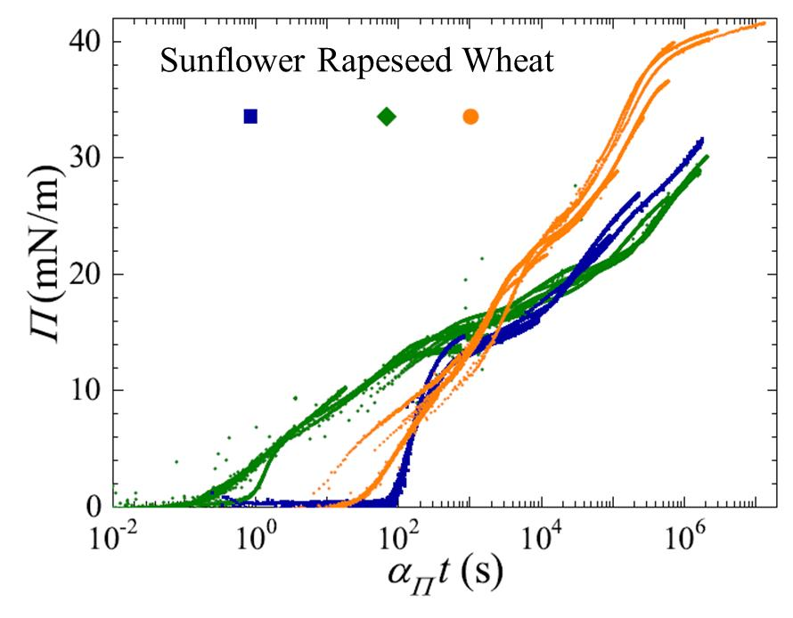
Figure 1: Air-water interface surface pressure master curves obtained for solutions of sunflower, rapeseed and wheat proteins comprised between 10⁻² and 10g/L.

References
[1] A. Poirier, A. Banc, A. Stocco, M. In, L. Ramos Journal of Colloid and Interface Science, 526 2018, 337 - 346.

