Heat-induced gelation of mixtures of casein micelles with whey protein aggregates
Anna Kharlamova¹, Taco Nicolai¹, and Christophe Chassenieux¹
1 Le Mans Université, IMMM UMR-CNRS 6283, Polymères, Colloïdes et Interfaces, 72085, Le Mans, cedex 9, France

E-mail contact: anna-kharlamova@yandex.ru

In this study we explore the functional properties of whey proteins found in the milk serum. Whey proteins are well known for their texturizing properties such as gelation, stabilization of foams and emulsions, film formation (Nicolai, Britten, and Schmitt, 2011). Current consumer demand for heathier, simpler ingredients in foods produced the terms such as “clean label” and “clean eating”. Whey proteins can be considered as an excellent “clean label” alternative to traditional E-number texturizing ingredients used in products, such as gelatine or modified starches, because they are percieved as healthy by most consumers and do not require approval by the European Food Safety Authority.
It was previously established that during heating at certain conditions whey proteins form suspensions of stable aggregates. Three types of aggregates with different functionality have been discribed in the literature – fractal aggregates, microgels and fibrils, with fractal aggregates having the most interesting functional properties for applications in food products. In particular, stable suspensions of fractal aggregates can form gels at ambient temperatures upon acidification or addition of salt – a process known as “cold gelation”. Cold gelation of whey protein fractal aggregates was previously studied in detail in our resarch group. It was found that cold gelation is a thermally activated process with an activation energy of 210 kJ/mol for gelation induced by addition of calcium chloride and 155 kJ/mol for acid-induced gelation (Kharlamova, Nicolai, and Chassenieux, 2018 a&b).
On the other hand, gelation of complex association colloids called casein micelles, that represent the major protein fraction in milk, was found to be characterized by a critical gelation temperature t_{c}. Gelation of micelles in water suspensions does not occur even after prolonged heating at tempratures below t_{c}, while happens almost immediately at and above t_{c} (Thomar & Nicolai, 2016).
In presented talk we discuss gelation of mixtures of casein micelles with whey protein fractal aggregates (Fig. 1). We show that addition of fractal aggregates to micelles results in formation of a hybrid protein network at a lower temperature. The mechanism of gelation of such systems is suggested. The results of the study can be used as a benchmark for application of whey protein aggregates as a gelling agent in more complex dairy systems.

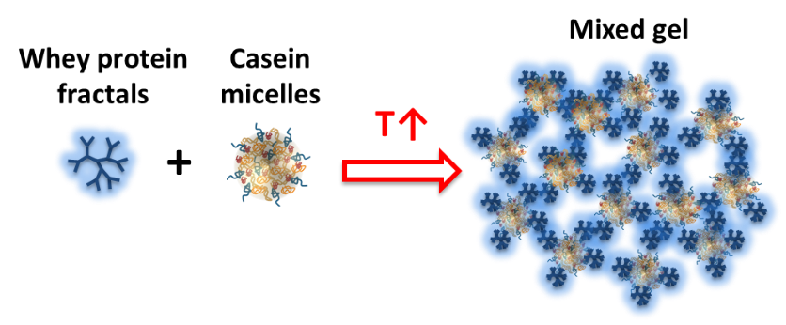
Figure 1: Schematic representation of gelation in mixtures of micelles with fractal whey protein aggregates.

References
[1] Nicolai, T., Britten, M. and Schmitt, C., 2011. β-Lactoglobulin and WPI aggregates: formation, structure and applications. Food Hydrocolloids, 25(8), pp.1945-1962.
[2] Kharlamova, A., Nicolai, T. and Chassenieux, C., 2018a. Calcium-induced gelation of whey protein aggregates: Kinetics, structure and rheological properties. Food hydrocolloids, 79, pp.145-157.
[3] Kharlamova, A., Chassenieux, C. and Nicolai, T., 2018b. Acid-induced gelation of whey protein aggregates: Kinetics, gel structure and rheological properties. Food hydrocolloids, 81, pp.263-272.
[4] Thomar, P. and Nicolai, T., 2016. Heat-induced gelation of casein micelles in aqueous suspensions at different pH. Colloids and Surfaces B: Biointerfaces, 146, pp.801-807.

