Gelation kinetics of sodium caseinate

induced by continuous acidification

Thomas Gibaud

Univ. Lyon, Ens de Lyon, Univ. Claude Bernard, CNRS, Laboratoire de Physique, F-69342 Lyon, France

E-mail contact: **thomas.gibaud@ens-lyon.fr**

Sodium caseinate is a milk protein which is used in pharmaceutical products and food. This protein is stable in water at pH=7 due to surface charges that induce an electrostatic repulsion. However, as the pH decreases and reaches this isoelectric point, pI=4.6, electrostatic repulsions vanish and the Van der Waals forces induces the flocculation of the caseinates. Here, we add GDL to the caseinate dispersion, a molecule that slowly and homogeneously reduces the pH from 7 to 3 and therefore leads to gelation [1]. Using a combination of rheology, X-ray scattering and confocal microscopy we study the gelation process.

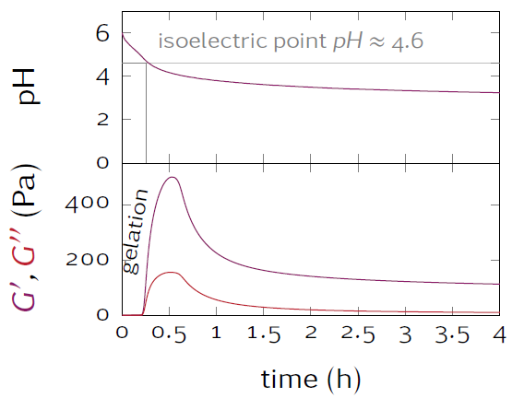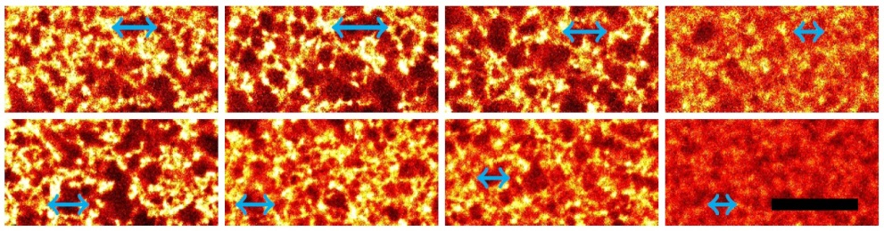

10 m

(a)

(b)

(c)

Figure 1: (a) rheology: evolution of the elastic G’ and loss G’’ modulus as a function of time and pH. (b) Saxs: evolution of the scattering intensity as function of the wave number q and time. (c) Confocal microscopy: snapshot of the gel at different times.

References

[1] Hierarchical wrinkling in a confined permeable biogel. M Leocmach, M Nespoulous, S Manneville, T Gibaud. Science Advances 1 (2015)