New approach for the characterisation
of dairy protein foams stability
Alexia Audebert¹, Sylvie Beaufils², Valérie Lechevalier¹, Cécile Le Floch-Fouéré¹, Arnaud Saint-Jalmes², Simon Cox³, Nadine Leconte¹, and Stéphane Pezennec¹
1 STLO, UMR1253, INRA, Agrocampus Ouest, F-35000, Rennes, France
2 Univ Rennes, CNRS, IPR (Institut de Physique de Rennes) - UMR 6251, F-35000, Rennes, France
3 Department of Mathematics, Aberystwyth University, Aberystwyth, Ceredigion, SY23 3BZ, United Kingdom

E-mail contact: stephane.pezennec@inra.fr

The main destabilisation processes in aqueous foams are liquid drainage, coalescence and disproportionation. In food sciences, the measurement of protein foam stability generally integrates all of them in a “global stability”, and a challenge is to correlate the stability and rheology of foams to the properties of interfaces.
We adopted a multi-scale approach by combining the interfacial rheology of proteins adsorbed at the air–water interface, the dynamics of protein films after T1 topological rearrangements (Fig. 1), and macroscopic foam characterisations: the foam stability against drainage was evaluated by following the evolution of the liquid fraction as a function of time and height (Fig. 2) [1], and the foam complex modulus and yield stress were measured under oscillatory shear. We investigated the behaviour of dairy proteins (whey protein isolate and purified β-lactoglobulin), either in the native state or after modification by dry-heating and/or pH adjustment prior to dehydration.
Our results show that small-extent structural modifications of proteins have a dramatic impact on interfacial rheology, liquid film dynamics, foam stability and foam rheology.
This approach, correlating multiple investigation scales, sheds light on the contribution of the interfacial rheology to protein foam properties, in particular through the involvement of film relaxation dynamics.
Figure 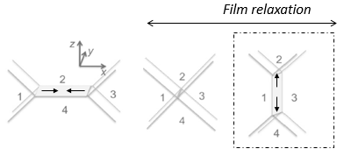1: T1 topological rearrangement between 5 films.
Figure 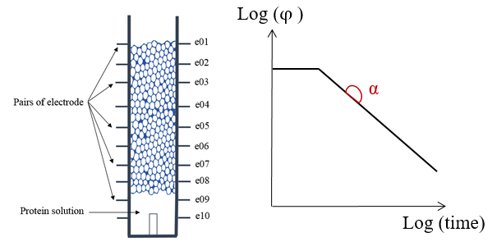2: Measurement of foam free drainage

References
[1] Audebert, A., Beaufils, S., Lechevalier, V., Le Floch-Fouéré, C., Saint-Jalmes, A., Pezennec, S., 2019. How foam stability against drainage is affected by conditions of prior whey protein powder storage and dry-heating: A multidimensional experimental approach. J. Food Eng. 242, 153–162. https://doi.org/10.1016/j.jfoodeng.2018.08.029

