Viscosity of artificial chewed boluses of cereal foods
Florence GIBOUIN, and Guy DELLA VALLE
INRA, Biopolymères, Interactions & Assemblages (UR1268 – BIA), 44316 Nantes, France

E-mail contact: florence.gibouin@inra.fr

Food Oral Processing (FOP) is a key step for foods assimilation and the benefit of their nutrient properties, especially for elderly whom oral physiology is altered. The main objective of this process is to form a food bolus that can be swallowed safely. Nevertheless, most of the studies about relationships between FOP, oral physiology and food bolus properties focus on particle size and dental status, saliva is only partly considered. However, for cereal products, food bolus viscosity is a function of the added saliva [1], which evidences the interaction between food and saliva. Our aim is to establish a model to determine a coefficient that characterizes this interaction.
To do so, we first study sponge cakes, one sample is standard and the other one is enriched with pea isolates. Artificial boluses composed of crushed sponge cake and a surrounding fluid, representative of saliva, are prepared. Four fluids are used: three of them are Newtonian, water and two Dextran solutions of viscosities 3mPa.s and 10mPa.s. The fourth fluid is shear thinning, composed of different salts and mucin distilled in water, as already used in different studies [2-4]. Viscosity measurements (shear and elongational) are realized using capillary rheometry, including Bagley’s corrections. The shear viscosity of boluses follows a power law model from which the consistency K can be derived. A phenomenological model of the consistency is obtained (Figure 1): K = K₀ e^{-α ΔWC}, where α is the interaction coefficient and ΔWC is the difference of water content between the food bolus and the sponge cake. Results also show that the viscosity plays a minor role, compared with its concentration. By varying properties of the surrounding fluid, the interaction between food and saliva can be assessed.
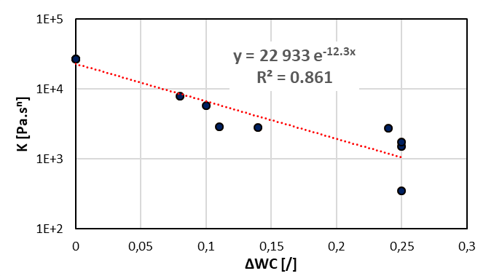

Figure 1: Phenomenological model of the consistency for a standard sponge cake. Red line is a fit by an exponential function that gives the interaction coefficient: α = 12.3.

This study is part of the project “Modelling interactions of Foods with SAliva during oral processing and application to the design of cereal foods enriched with plant proteins (MoFooSA)” that has been supported by the Region Pays de Loire, via the RFI project “Food for tomorrow”.

References
[1] Assad-Bustillos M., Tournier C., Septier C., Della Valle G. & Feron G., “Relationships of oral comfort perception and bolus properties in the elderly with salivary flow rate and helth status for two soft cereal foods”, Food Research International (2017).
[2] Chen J., “Food oral processing – A review”, Food Hydrocolloids 23: 1-25 (2009).
[3] Odake S., Roozen J.P. & Burger J.J., “Flavor release of diacetyl and 2-heptanone from cream style dressings in three mouth model systems”, Bioscience, Biotechnology and Biochemistry 64: 2523-2529 (2000).
[4] van Ruth S.M., Roozen J.P. & Cozijnsen J.L., “Changes in flavour release from rehydrated diced bell peppers (Capsicum annuum) by artificial saliva components in three mouth model systems”, Journal of the Science of Food and Agriculture 67: 189-196 (1995).

