Acid-induced gel properties of an alginate-in-whey protein emulsion

Ashkan Madadlou¹, Arnaud Saint-Jalmes², Stéphane Pezennec¹, Marie-Helene Famelart¹, Florence Rousseau^{1,} Juliane Floury¹, Didier Dupont¹

¹ STLO, UMR 1253, INRA, Agrocampus Ouest, F-35000 Rennes, France
² Univ Rennes, CNRS, IPR (Institut de Physique de Rennes) - UMR 6251, F-35000 Rennes, France

E-mail contact: didier.dupont@inra.fr
Water-in-water (W/W) or aqueous two-phase system (ATPS) emulsions are finding increasing applications in diverse fields of technology, for instance as protocells [1], and reactors for the synthesis of hydrogel particles [2], and enzyme-laden microgels [3]. Successful ATPS emulsification depends on thermodynamic incompatibility between two (bio)polymers, causing segregative phase separation [4]. Herein, we demonstrate that hydrophobization of whey proteins, by grafting acetyl moieties and heat denaturation, makes the proteins immiscible with a co-charged polysaccharide solution (alginate). Addition of erythritol, which is a low-calorie and zero-glycemic sugar alcohol, to the hydrophobized protein solution, enhanced emulsification and increased the stability of the resulting emulsion. Subsequently, the acid-induced gel properties of the emulsion was studied by dynamic rheometry and confocal microscopy.
Erythritol addition reduced the surface tension (at the air-water interface) of the hydrophobized protein solution, enhancing the incompatibility between protein and alginate. It also postponed the gelation time of the hydrophobized protein solution and resulted in formation of a softer gel. Confocal imaging of the emulsion gel confirmed micro-phase separation of alginate and the droplets aggregation in the protein-rich matrix.

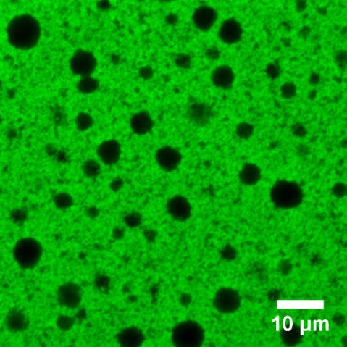
A B

Fig. 1. A: G’, storage (circles) and G’’, loss (cubes) moduli of the alginate-in-whey protein emulsion gel measured by a frequency sweep test; and B: a typical CLSM image of the emulsion gel.

References

[1] D.C. Dewey, C.A. Strulson, D.N. Cacace, P.C. Bevilacqua, C.D. Keating, Bioreactor droplets from liposome-stabilized all-aqueous emulsions, Nat. Commun. 5 (2014). doi:10.1038/ncomms5670.
[2] Y. Song, U. Shimanovich, T.C.T. Michaels, Q. Ma, J. Li, T.P.J. Knowles, H.C. Shum, Fabrication of fibrillosomes from droplets stabilized by protein nanofibrils at all-aqueous interfaces, Nat. Commun. 7 (2016). doi:10.1038/ncomms12934.
[3] Y. Beldengrün, J. Aragon, S.F. Prazeres, G. Montalvo, J. Miras, J. Esquena, Gelatin/Maltodextrin Water-in-Water (W/W) Emulsions for the Preparation of Cross-Linked Enzyme-Loaded Microgels, Langmuir. 34 (2018) 9731–9743. doi:10.1021/acs.langmuir.8b01599.
[4] J. Esquena, Water-in-water (W/W) emulsions, Curr. Opin. Colloid Interface Sci. 25 (2016) 109–119. doi:10.1016/j.cocis.2016.09.010.

